|  |  |  |  |  |  |
| --- | --- | --- | --- | --- | --- |
| **Key Vocabulary** | | | | | |
| **Stride/s -** are a fair way short of outright sprinting. Athletes try to stride at about two-thirds of their top speed. | **Special Awareness -** Spatial awareness is, an organised awareness of the objects in the space around us, and also an awareness of our body's position in that space. | | **Trajectory -** the path followed by an object moving under the action of given forces. | | **Agility -** is the ability to rapidly change body direction, accelerate, or decelerate. |
| **What you need to be successful?** | | | | | |
| **How to sprint successfully – acceleration.** | | **How to throw a javelin successfully.** | | **How to slow down my run successfully - deceleration** | |
| * You need to get from one end to the other in the quickest time possible. * Quick, light movements on your feet. * Lean forward. * Do not forget to pump your arms. | | * Lean back with wide base (bow shape). * Sidewards stance with non-throwing arm high. * Long arm and palm. | | * You need to slow down to either finish your run or to change direction. * Lean back, particularly your shoulders. * Stop pumping your arms. | |
| **Building Blocks to Success** | | | | | |

**Pictures of Skills**

**Acceleration**

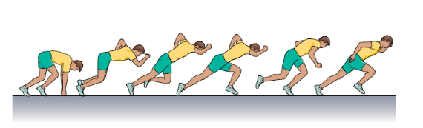

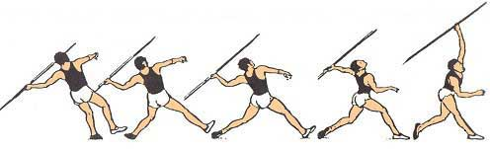

**Javelin**

**Deceleration**

